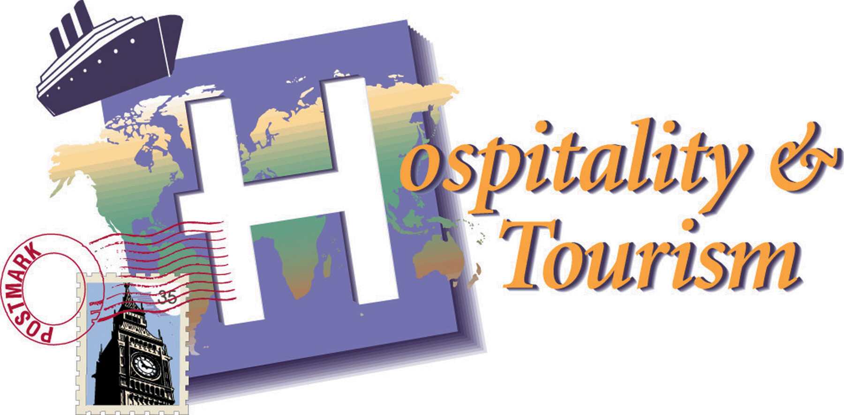

Mr. Lieberman
slieberman@pobschools.org

THE COURSE
Hospitality and tourism are topics that you can relate to and make your own. Many people travel and stay in lodging facilities and go to restaurants. These exciting businesses continue to grow and employ a vast number of people. This course will teach you about travel, tourism, lodging and food- service industries. It will also help you develop skills which will help you succeed in your future careers. Working for hospitality and tourism businesses requires training, experience and personal skills for employees as well as managers. You will learn that success in hospitality and tourism, like success in any career field, also requires responsibility, self - management, leadership and integrity.

COURSE OUTLINE
- Hospitality and Tourism – Industry definition, and an explanation of how it affects various economic markets. What is Hospitality? What is Tourism?
- Hospitality and Tourism Marketing – Applying basic marketing concepts to the Hospitality and Tourism.
- Careers in Hospitality and Tourism – Explore the various jobs available and industry outlook in regards to the Hospitality and Tourism industry.
- Customer Service – What does it take to ensure customers keep coming back? Why is this important to the Hospitality and Tourism industry?
- Hospitality and Tourism Niche Market – What would you do to ensure a prosperous and successful Hospitality and Tourism outlet?
GRADING
- 60%--Tests, Projects
- 20%--Classwork / Homework
- 20%--Participation (1 cut = 3 lates = 1 point off quarter grade)
- Final Project 20% of Final Grade (Career Project)

